In caAERS, you can add a study by manually filling in pages under the Studies tab, which is described in this topic or you can contact and have your caAERS administrator import an XML file comprising the study information. Once a study is entered in caAERS, you can search for a study, edit a study, and also export the study to an XML file for further import into another caBIG product.
Note: All required fields in caAERS have a red asterisk next to them. This means you must complete the field to save and continue to the next page. Based on the user role assigned to you by the caAERS administrator and how the product was configured, you may not have access to all the fields and pages described in this topic.

Contents
[hide]
- 1 Updating a Broadcasted Study from C3PR - caBIG Clinical Trials Suite Users Only
- 2 Creating a New Study in caAERS
  - 2.1 Entering Details About the Study
  - 2.2 Associating Therapies with a Study
  - 2.3 Adding Agents to a Study
  - 2.4 Assigning Treatments to a Study
  - 2.5 Associating Diseases with a Study
    - 2.5.1 For CTEP Disease Classification
    - 2.5.2 For MedDRA Disease Classification
    - 2.5.3 For Other-Specify Disease Classification
  - 2.6 Adding Solicited Adverse Events to Evaluation Periods
  - 2.7 Adding Expected Adverse Events
  - 2.8 Assigning Sites to a Study
  - 2.9 Adding Investigators to an Associated Study Site
  - 2.10 Adding Personnel to an Associated Study Site
  - 2.11 Adding System and Organization Identifiers to a Study
  - 2.12 Reviewing the Study Overview
- 3 Searching for a Study
- 4 Searching for a Study in NCI Enterprise Services - caBIG Clinical Trials Suite Users Only
- 5 Reviewing and Editing Study Details
- 6 Exporting a Study to an XML File

Updating a Broadcasted Study from C3PR - caBIG Clinical Trials Suite Users Only
If you received an alert on the Comments/Alerts tab that a new study was added from another Suite application, you can update the study with caAERS information. For important information about entering studies in The Suite, see to caBIG Clinical Trials Suite, Chapter 5

Creating a New Study in caAERS
If you cannot enter all the information for the study in one sitting, complete the section you are on and then click the Overview section tab. This will allow you to save the study. To finish entering the information into the study at a later time, search for your saved study (see Searching for a Study) and continue entering information.
Note: If you want to import a study file from a local clinical trials management system (CTMS), contact your caBIG caAERS Administrator.
For caBIG Clinical Trials Suite Users For prerequisite information about creating a study, see Create a Study with the Suite.
To add a study to caAERS
[[Image:ThreeLevels.jpg
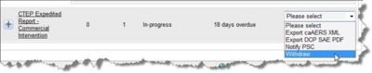
]]
- Click the Studies tab in the navigation bar.
- Click Enter Study. The Basic Details page opens.
- You will add the following information to create a study in caAERS:
  - Enter general information
  - Associate therapies
  - Adding agents
  - Assigning treatments
  - Associate diseases
  - Add solicited adverse events to evaluation periods
  - Add expected adverse events
  - Assign sites
  - Add investigators to a study site
  - Add personnel to a study stie
  - Add identifiers
  - Review the overview

Entering Details About the Study
The Study Details page (see Creating a New Study in caAERS and follow the procedure to access this page) enables you to enter general information about the study.
Note: To ensure proper communication with AdEERS, select Yes for AdEERS reporting.
To enter details about the new study
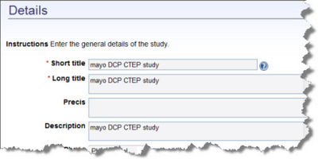
- Fill in the following information.
  - Short Title is the title for which the public will know the study as defined in the protocol.
  - Long Title is the official title as provided entered by the principal investigator or sponsor.
  - Precis is short description of the primary purpose of the study.
  - Description Optional. A detailed description of the study, including information not covered by other fields, such as comparison studies.
- Select the Phase of the study.
  - Phase 1 are initial studies to determine the metabolism and pharmacologic actions of drugs in humans, the side effects associated with increasing doses, and to gain early evidence of effectiveness; may include healthy participants and/or patients.
  - Phase II are controlled clinical studies conducted to evaluate the effectiveness of the drug for a particular indication or indications in patients with the disease or condition under study and to determine the common short-term side effects and risks.
  - Phase III are expanded, controlled, and uncontrolled trials after preliminary evidence suggesting effectiveness of the drug has been obtained, and are intended to gather additional information to evaluate the overall benefit-risk relationship of the drug and provide and adequate basis for physician labeling.
  - Phase IV are post-marketing studies to delineate additional information including the drug's risks, benefits, and optimal use.
  - Pilot
  - N/A
- Select the Status of the study.
  - Active The trial is in progress.
  - Administratively Complete The trial is complete and all of the administration and paperwork is complete.
  - Approved
  - Closed to Accrual and Treatment No additional subjects
  - Closed to Accrual No Treatment Additional subjects will be enrolled in the study. Study activity is ongoing and may include intervention or interaction with subjects, continued use of a drug or device, and/or data analysis.
  - Temporarily Closed to Accrual and Treatment For a period of time, no subjects will be added and treatment will be discontinued.
  - Temporarily Closed to Accrual For a period of time, no subjects will be enrolled in the study. Study activity is ongoing and may include intervention or interaction with subjects, continued use of a drug or device, and/or data analysis.
  - In Review The trial is in review and has not been approved.
  - Disapproved The trial was not approved.
  - Complete The study is complete.
- Specify whether the trial is Multi Institutional or there are multiple sites.
- Specify whether AdEERS reporting is required. If you are using Disease Coding using MedDRA or CTEP files, specify Yes for automated expedited reporting. If you are using user-defined coding, select No as caAERS cannot communicate with AdEERS for automatic reporting.
- Indicates the Data Entry Status.
- Specify AE Terminology, the adverse event dictionary:
  - CTC (see CTC Adverse Event Coding)
  - MedDRA (see MedDRA Adverse Event Coding)
- Specify the CTC Version. If you select CTC, select the version to apply.
  - CTC v2.0
  - CTCAE v3.0
  - CTCAE v4.0
- Specify the MedDRA Version The. . .MedDRA v9, MedDRA v10
- Specify the Disease Coding Terminology
  - CTEP (see CTEP Disease Classification)
  - MedDRA (see MedDRA Disease Classification)
  - Other-Specify (see User-Defined Disease Classification)
- Specify the Study Design
  - Blind is where participants are not aware of what treatment they are receiving.
  - Open/Blind is where some participants are not aware of what treatment they are receiving and some are aware.
  - Unblind
- Expedited Report Formats specifies how users can export data from caAERS. If you need to export information to any of the organizations listed, select the option.
  - caAERS XML generates an XML file of caAERS data. To update other caBIG applications with caAERS data, check this box.
  - AdEERS PDF is the Adverse Event Expedited Reported System.
  - CIOMS Form is the Council for International Organizations of Medical Sciences form which for standardized international reporting of individual cases of serious, unexpected adverse drug reactions.
  - CIOMS SAE Form is the Council for International Organizations of Medical Sciences Serious Adverse Event form.
  - DCP SAE Form is the Division of Cancer Prevention Serious Adverse Event form.
  - MedWatch PDF is the FDA Safety Information and Adverse Event Reporting System form.
- Fill in the following information as needed.
  - Coordinating Center and Coordinating Center Identifier A group organized to coordinate the planning and operational aspects of a multi-center clinical trial. Enter the first few letters of the name of the Coordinating center and select it from the drop down list that appears. Note: This is an auto-populated field. If the name you are looking for is not in the drop down list that appears, contact your caAERS system administrator.
  - Funding Sponsor and Funding Sponsor Identifier The funding sponsor is the entity sponsoring the study. Enter the first few letters of the name of the Funding sponsor and select it from the drop down list that appears.
- To save your changes, click Save.
  - To save your changes and return to the previous page, click Save and Back.
  - To save your changes and continue to the Therapies page, click Save and Continue.
Note: If you cannot enter all the information for the study in one sitting, complete the section you are on and then click the Overview section tab. This will allow you to save the study. To finish entering the information into the study at a later time, search for your saved study Searching for a Study.

Associating Therapies with a Study
On the Therapies page (see Creating a New Study in caAERS and follow the procedure to access this page) you can associate the appropriate therapies to the current study.
To associate therapies with the study
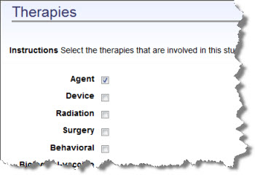
- Check the the boxes of any therapies that will be used to treat a participant in the study:
  - Agent therapy involves taking medicine, vitamin, mineral, or food supplements.
  - Device therapy is where a device may be implanted in the participant.
  - Radiation therapy is a local treatment that acts only on the part of the body that is exposed to the radiation.
  - Surgery therapy is a surgery at an intervention site.
  - Behavior therapy uses basic learning techniques to modify maladaptive behavior patterns by substituting new, positive responses.
  - Biological Vaccine is a preparation of live microorganisms or their toxins, introduced by mouth, by injection, or by nasal spray to stimulate production of antibodies against an infectious agent.
  - Genetic therapy is a technique for correcting defective genes responsible for disease development.
  - Dietary therapy is a change in the participant's diet.
  - Other
- To save your changes, click Save.
  - To save your changes and return to the previous page, click Save and Back.
  - To save your changes and continue to the Agents page, click Save and Continue.
Note: If you cannot enter all the information for the study in one sitting, complete the section you are on and then click the Overview section tab. This will allow you to save the study. To finish entering the information into the study at a later time, search for your saved study Searching for a Study.

Adding Agents to a Study
If you selected Agent on the Therapies page (see Creating a New Study in caAERS and follow the procedure to access this page), you can add agents to a study on the Agents page. An agent is a medication, vitamin, mineral, or food supplement. To skip this step, click the Treatment Assignments tab for Assigning Treatments to the Study.
To add an agent to a study
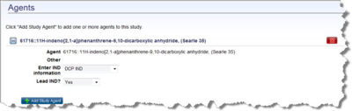
- Click Add Study Agent.
- Enter the first few letters of the name of the Agent. If the agent is in caAERS, the name appears in the drop down list. If the agent's name does not appear in the drop down list, enter the agent name in Other.
- For Enter IND Information specify the organization associated with the Investigational New Drug (IND) to ensure that the research is conducted in accordance with Federal regulations.
  - N/A-Commercial Agent
  - IND-Exempt
  - DCP IND Division of Cancer Prevention (DCP) IND
  - Other IND Holder
  - CTEP IND is the Cancer Therapy Evaluation Program (CTEP) IND
- Specify whether this is the Lead IND, a lead Investigational New Drug (IND).
- Click Save and the new agent is added to the list.
  - To add another agent, click Add Study Agent.
  - To edit an existing agent, click the plus sign to the left of the agent name. Make changes and click Save.
  - To delete an existing agent, click the x sign to the right of the agent name.
- To save the changes, click Save.
- Once you are complete adding the agents:
  - To save your changes and return to the previous page, click Save and Back.
  - To save your changes and continue to the Treatment Assignments page, click Save and Continue.
Note: If you cannot enter all the information for the study in one sitting, complete the section you are on and then click the Overview section tab. This will allow you to save the study. To finish entering the information into the study at a later time, search for your saved study Searching for a Study.

Assigning Treatments to a Study
If there are treatment assignments associated with the study, you can add them using the Treatment Assignments page (see Creating a New Study in caAERS and follow the procedure to access this page). A treatment assignment can be an "ARM" or a cohort. An ARM is a treatment group in a randomized trial. Most randomized trials have two "ARMs," but some have three "ARMs," or even more. A cohort is a group of individuals with some characteristics in common.
To add a treatment assignment to a study
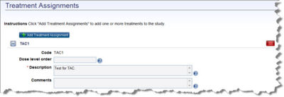
- Click Add Treatment Assignment.
- Enter the Code. This is the code for the treatment that is found in the protocol.
- Enter the Dose level order, if desired.
- Enter a complete Description of the treatment including the agent name, dose, route, frequency.
- Enter Comments to specify additional notes about the treatment, if desired.
- Click Save.
- To edit an existing treatment, click the plus sign to the left of the name. Make changes and click Save. To delete an existing treatment, click the x sign to the right of the name. To save the changes, click Save.
- Once you complete adding the treatment assignments:
  - To save your changes and return to the previous page, click Save and Back.
  - To save your changes and continue to the Disease page, click Save and Continue.
Note: If you cannot enter all the information for the study in one sitting, complete the section you are on and then click the Overview section tab. This will allow you to save the study. To finish entering the information into the study at a later time, search for your saved study Searching for a Study.

Associating Diseases with a Study
When you associate a disease with a study, the "disease" may be a disease or a condition that needs to be monitored during the trial. The Disease page (see Creating a New Study in caAERS and follow the procedure to access this page) varies based on the disease terminology you selected on the Study Details page: CTEP, MedDRA, or Other/Specify disease classification.
To associate a disease with a study:
Note: You must fill in at least one disease on this page to continue to the next step.
- Fill in CTEP fields
- Fill in MedDRA fields
- Fill in Other/Specify fields

For CTEP Disease Classification
To specify CTEP information
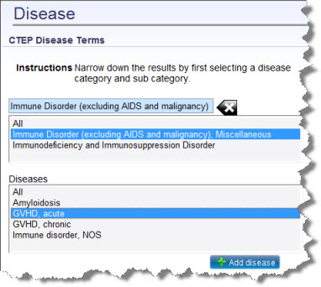
- Enter the first few letters of the disease begin typing here. Diseases with the same starting letters fill the drop down list. Select the appropriate name, and the disease sub-categories and diseases populate the list boxes on the left side.
- Select one sub-category to list only the diseases for that sub-category or select All to list diseases for the whole category.
- Select one Disease from the bottom list box or All diseases.
- Once the appropriate disease(s) for the study are highlighted, click Add disease. The diseases and the associated conditions are added to the study on the right side.
- To specify a primary disease for the study, select Primary next to the disease term. To remove a disease from the study, click the x sign next to the disease term. The primary disease is the main disease being treated in the clinical trial.
- Click Save.
- Once you complete adding diseases:
  - To save your changes and return to the previous page, click Save and Back.
  - To save your changes and continue to the Evaluation Period Types and Solicited Adverse Events page, click Save and Continue.

For MedDRA Disease Classification
To specify MedDRA information
- Enter the first few letters of the disease term begin typing here. Terms with the same starting letters fill the drop down list. Select the appropriate term, and the name fills in.
- Once the appropriate term is selected, click Add disease. The disease is added to the study on the right side.
- To specify a primary disease for the study, select the button next to the disease term. To remove a disease from the study, click the x sign next to the disease term. The primary disease is the main disease being treated in the clinical trial.
- Click Save.
- Once you complete adding diseases:
  - To save your changes and return to the previous page, click Save and Back.
  - To save your changes and continue to the Evaluation Period Types and Solicited Adverse Events page, click Save and Continue.

For Other-Specify Disease Classification
To specify information for the user-defined disease classification
- Enter the first few letters of the disease or condition term begin typing here. Terms with the same starting letters fill the drop down list. Select the appropriate term, and the names fills in.
- Once the appropriate term is selected, click Add disease. The disease is added to the study on the right side.
- To specify a primary disease for the study, select the button next to the disease term. To remove a disease from the study, click the x sign next to the disease term. The primary disease is the main disease being treated in the clinical trial.
- Click Save.
- Once you complete adding diseases:
  - To save your changes and return to the previous page, click Save and Back.
  - To save your changes and continue to the Evaluation Period Types and Solicited Adverse Events page, click Save and Continue.
Note: If you cannot enter all the information for the study in one sitting, complete the section you are on and then click the Overview section tab. This will allow you to save the study. To finish entering the information into the study at a later time, search for your saved study Searching for a Study.

Adding Solicited Adverse Events to Evaluation Periods
The Evaluation Period Types & Solicited Adverse Events page (see Creating a New Study in caAERS and follow the procedure to access this page) enables you to add evaluation period information for the study. An evaluation period types is a portion of the study containing one or more study segments with a consistent objective, such as screening subjects or treating disease. No subject can take part in more than one Evaluation Period Type at any point in time. Solicited adverse events are entered with the initial study information in the system, and these are events where information is captured if they occur. For example, it may be requested that "Nausea" be evaluated during a "Treatment" reporting period type.
To add solicited adverse event terms to a study
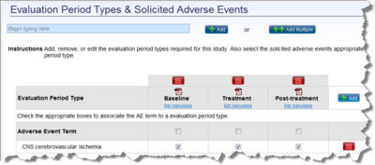
- Enter the adverse event term or a portion of the term name. Select the adverse event term from the list, and click Add.
  - For example, if you type fever the following names populate the list: Allergic reaction/hypersensitivity (drug fever) or Fever in the absense of neutropenia
  - If you type allergic, the following names populate the list: Allergic reaction/hypersensitivity (drug fever) or Allergic rhinitis (including sneezing, nasal stuffiness, postnasal drip.
- If you selected CTC for Adverse Event Terminology on the Details page, you can add multiple adverse event terms. To add more than one, click Add Multiple.
  - Select the appropriate AE Category. The terms associated with the category display under AE terms.
  - Click the AE Terms to add to the study, and the terms display under Selected Terms. To deselect a selected term, uncheck the box.
  - To add the solicited adverse eents to the study, click Add Terms.
- The added AE term(s) are listed under Adverse Event Term. The default evaluation periods are Baseline, Treatment, and Post-Treatment, but you can change them as needed (see the next section to manage evaluation periods).
To manage the evaluation periods for the study
- To add an evaluation period to the study, click Add to the right side of the evaluation period row.
- Enter the name of the evaluation period and click OK.
- To open and print a blank adverse event worksheet for this evaluation period, see Printing a Blank Adverse Event Worksheet.
- Click Edit Instructions to provide instructions on how to fill out the blank worksheet.
- Click Save.
- To change an existing evaluation period, click the name, change the name, and click Ok. You can also edit the instructions.
- To delete an existing evaluation period, click the x above the evaluation period name. The message Do you really want to delete this treatment period? appears. Click Yes.
- Once the evaluation periods are defined, you can add adverse event terms to each evaluation period.
  - To add an individual adverse event term to an evaluation period, check the box across individual term under the appropriate period.
  - To add all the adverse event terms, click the box in the shaded row Adverse Event Terms under the evaluation period.
To save your changes
- Click Save.
  - To save your changes and return to the previous page, click Save and Back.
  - To save your changes and continue to the Expected AEs page, click Save and Continue.
Note: If you cannot enter all the information for the study in one sitting, complete the section you are on and then click the Overview section tab. This will allow you to save the study. To finish entering the information into the study at a later time, search for your saved study Searching for a Study.

Adding Expected Adverse Events
On the Expected AEs page (see Creating a New Study in caAERS and follow the procedure to access this page), enter the expected adverse events listed on the protocol. When you enter the expected adverse events in the study, caAERS will monitor them and automatically flag adverse events specified as Expected. This information will then be used by the caAERS rules to help determine reports to generate.
To add expected adverse terms to a study
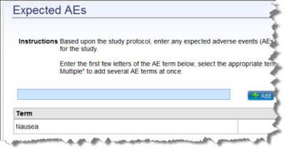
- Enter the AE Term or a portion of the adverse event term .
  - For example, if you type fever the following names populate the list: Allergic reaction/hypersensitivity (drug fever) or Fever in the absense of neutropenia
  - If you type allergic, the following names populate the list: Allergic reaction/hypersensitivity (drug fever) or Allergic rhinitis (including sneezing, nasal stuffiness, postnasal drip.
- Select the adverse event term from the list and click Add.
- If you selected CTC for Adverse Event Terminology on the Details page, you can add multiple adverse event terms. To add more than one, click Add Multiple.
  - Select the appropriate AE Category. The terms associated with the category display under AE terms.
  - Click the AE Terms to add to the study, and the terms display under Selected Terms. To deselect a selected term, uncheck the box.
  - Click Add Terms.
- The added AE term(s) are listed under Term.
- Click Save.
  - To save your changes and return to the previous page, click Save and Back.
  - To save your changes and continue to the Sites page, click Save and Continue.
Note: If you cannot enter all the information for the study in one sitting, complete the section you are on and then click the Overview section tab. This will allow you to save the study. To finish entering the information into the study at a later time, search for your saved study Searching for a Study.

Assigning Sites to a Study
On the Sites page (see Creating a New Study in caAERS and follow the procedure to access this page) you must assign at least one site to specify where the clinical trial is being performed, but you can also assign more than one site if needed.
To assign a site to a study
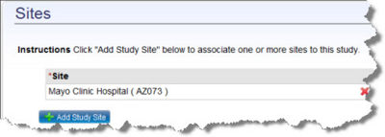
- Click Add Study Site.
- Enter the first few letters of the site name or a word within the site name.
  - For example, if you type mayo the following may appear in the list: Mayo Clinic Hospital or Henry Mayo Newhall Memorial Hospital.
- Select the site from the list.
- Click Save. The site is added to the list.
  - To delete a site, click the x next the site name. Click Ok.
- To save your changes, click Save.
  - To save your changes and return to the previous page, click Save and Back.
  - To save your changes and continue to the Investigators page, click Save and Continue.
Note: If you cannot enter all the information for the study in one sitting, complete the section you are on and then click the Overview section tab. This will allow you to save the study. To finish entering the information into the study at a later time, search for your saved study Searching for a Study.

Adding Investigators to a Study Site
The Investigators page (see Creating a New Study in caAERS and follow the procedure to access this page) enables you to associate investigators with the study who work at an associated site, There are different types of investigators to associate with a study including:
- Principal investigator is one medical researcher in charge of carrying out the clinical trial's protocol.
- Site investigator is a physician who is part of the study and treating patients with the protocol.
- Site principal investigator is a physician in charge of the trial who is also treating patients with the protocol.
To add an investigator to a study site
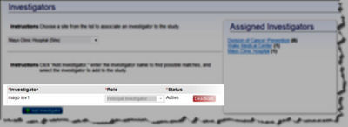
Note: All the sites associated with the study are listed under Assigned Investigators. The number of investigators assigned to each site is shown in parentheses. For a summary of site information, click the site name and the blue summary at the top of Investigators page displays the selected site's information.
- Select a site from the drop down list. Any investigators already associated with that site automatically appear. If a site is not listed, contact your caAERS administrator.
- To find an investigator, enter the first few letters of the investigator's name or characters within the name.
  - For example, if you type alex the following may appear in the list: Alexandra Jones or Alexander Johnson.
- Select the investigator from the list.
- Click Add Investigator.
- From the Role list, select Principal Investigator, Site Investigator, or Site Principal Investigator.
- The Status is Pending. When the status is pending you can still remove the investigator from the site.
- Click Save. The investigator is associated with the site and is added to the total number of investigators under Assigned Investigators.
  - To delete a site, click the x next the site name. Click Ok.
- To save your changes, click Save.
  - To save your changes and return to the previous page, click Save and Back.
  - To save your changes and continue to the Personnel page, click Save and Continue.
Note: If you cannot enter all the information for the study in one sitting, complete the section you are on and then click the Overview section tab. This will allow you to save the study. To finish entering the information into the study at a later time, search for your saved study Searching for a Study.

Adding Personnel to a Study Site
The Research Staff page (see Creating a New Study in caAERS and follow the procedure to access this page) enables you to associate research staff at a coordinating center or sponsor site with a study.
To add staff to a study
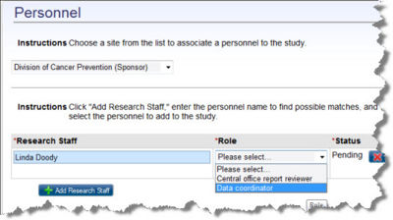
- Select a site from the drop down list. Any personnel already associated with that site automatically appear.
- To add a staff member, enter the person's name or a portion of the name.
  - For example, if you type alex the follow may appear in the list: Alexandra Jones Clinic Hospital or Alexander Johnson.
- Select the staff member from the list.
- Click Add Personnel.
- From the Role list, select the appropriate role:
- Click Save.
- The Status is Pending. Note that as long as the status is Pending and not saved, you can remove the subject from study.
- Click Save. The staff member is associated with the site and is added to the total number of personnel under Assigned Personnel.
  - To delete a staff member, click the x next the name. Click Ok.
- To save your changes, click Save.
  - To save your changes and return to the previous page, click Save and Back.
  - To save your changes and continue to the Identifiers page, click Save and Continue.
Note: If you cannot enter all the information for the study in one sitting, complete the section you are on and then click the Overview section tab. This will allow you to save the study. To finish entering the information into the study at a later time, search for your saved study Searching for a Study.

Adding System and Organization Identifiers to a Study
On the Identifiers page (see Creating a New Study in caAERS and follow the procedure to access this page), you can associate two types of identifiers with the study:
- System identifiers enable users of other applications to find the study because the application's ID for the study is entered here.
- Organization identifiers enable users from associated sites, like ClinicalTrials.gov, Mayo Clinic, Wake Forest or Duke University, to find the study because the organization's ID for the study is entered here.
This creates a map of IDs so that different users in different areas can find the same study using different IDs.
Note: caAERS automatically adds two organization identifiers, based on what was entered for the Coordinating Center and the Funding Sponsor on the study Details page. The Coordinating Center will be listed as the primary indicator.
To associate identifiers with this study
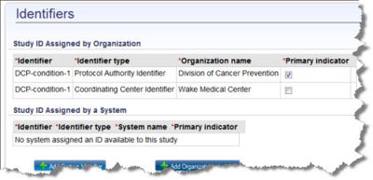
- To add a system identifier, click Add System Identifier.
  - Enter the new Identifier.
  - Select an Identifier Type from the list.
  - Enter the system name.
  - Specify the Primary Indicator. Note: If another identifier was specified as the Primary Indicator that box is unchecked.
  - Click Save. The added identifiers are associated with the study.
    - To delete an identifier, click the x next the name. Click Ok.
- To add an organization identifier, click Add Organization Identifier.
  - Enter the new Identifier.
  - Select an Identifier Type.
  - Enter the organization name.
  - Specify the Primary Indicator to indicate how the study will normally be identified.
  - Click Save. The added identifiers are associated with the study.
    - To delete an identifier, click the x next the name. Click Ok.
- To save your changes, click Save.
  - To save your changes and return to the previous page, click Save and Back.
  - To save your changes and continue to the Overview page, click Save and Continue.
Note: If you cannot enter all the information for the study in one sitting, complete the section you are on and then click the Overview section tab. This will allow you to save the study. To finish entering the information into the study at a later time, search for your saved study Searching for a Study.

Reviewing the Study Overview
The Overview page (see Creating a New Study in caAERS and follow the procedure to access this page) summarizes all the information entered about the study. Review the information provided. If there are changes that you need to make, click Back or click the appropriate tab to move to the page to update.
If the study is complete, click Save. A confirmation page opens showing the short title, primary identifier, coordinating center, funding sponsor, and phase.
For caBIG Clinical Trials Suite Users Only
If you have completed data entry for a study broadcasted from C3PR, click the Study Setup Complete button. This enables Suite users to associate subjects with the study.
To export a study to an XML file, see Exporting a Study to an XML File.

Searching for a Study
When you search for a study, you can fill in one or all fields completely or partially. You can also leave all the fields blank so that all studies are listed in the results.
To access the Search Criteria page for a study
Note: If you want to search for a study using multiple criteria, see Performing Advanced Searches with caAERS.
- Click the Studies tab in the navigation bar.
- Click Search Studies. The Search Criteria page opens.
To search for a study
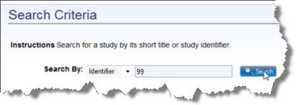
- Drop down the Search By list and select whether you want to search for a study based on the title or identifier. If you enter % in the box, all studies will display.
  - Short Title Enter the entire title of the study or a portion of the text. Select a title from the list.
  - Identifier Enter the entire identifier or a portion of the identifier. Select an identifier from the list. For example, if you enter MC any study with MC anywhere in the identifier will be found. The identifier comprises an Organization and a System Identifier. An Organization Identifier is a number or code assigned by the organization who runs the study (such as Mayo Clinic, Wake Forest or Duke University). The System Identifier is assigned by caAERS and identifies the Coordinating Center and the Funding Sponsor.
- Click Search. The Results display.
- From the Results page, you can perform the tasks described in Finding a Search Result.
- When you find the study, click the row and the Overview page opens. See Reviewing and Editing Study Details.

Searching for a Study in NCI Enterprise Services - caBIG Clinical Trials Suite Users Only
The NCI Enterprise Services is a reposity of clinical trial protocol abstraction, persons, organizations, and the associations between them. As a caAERS Suite user, you can search for a study within NCI Enterprise Services, and update the information on NES from caAERS. You may experience some delays if NCI Enterprise Services (COPPA) mode is enabled. To find a study in NES, see Suite User's Guide, Chapter 9

Reviewing and Editing Study Details
To review and edit a study
- Search for the study you want to change (see Searching for a Study).
  - From the Overview page, you can export all the study information to an XML file. This file can be imported from other caBIG products eliminating the need for extra data entry.
- If you need to make changes to the study information, the numbered tasks at the top of the page access all the study information that you update.
  - Click Details and see Entering Details About the Study.
  - Click Therapies and see Associating Therapies with a Study.
  - Click Agents and see Adding Agents to a Study.
  - Click Treatments and see Assigning Treatments to a Study.
  - Click Diseases and see Associating Diseases with a Study.
  - Click Solicited AEs and see Adding Solicited Adverse Events to Evaluation Periods.
  - Click Expected AEs and see Adding Expected Adverse Events (AEs).
  - Click Sites and see Assigning Sites to a Study.
  - Click Investigators and see Adding Investigators to an Associated Study Site.
  - Click Personnel and see Adding Personnel to an Associated Study Site.
  - Click Identifiers and see Adding System and Organization Identifiers to a Study.
- Once data entry for the study is complete and correct, click Overview to display the Overview page.
- Click Study Set-up Complete. The Data Entry Status changes from Inprogress to Complete.
- To export the study information to an XML file, see Exporting a Study to an XML File.

Exporting a Study to an XML File
To export a study to an XML file, you need to either enter the study (Creating a New Study) or search and find a study (Searching for a Study). Then click the Overview task to display the Overview task page.
To export study information to an XML file
- From the Overview Study page click
.
- Do you want to Open or Save this File?
  - If you click Open, the XML file appears in a window. You can Save As, Print, or perform any of the options accessible from the menus.
  - If you click Save, you are prompted to enter a file name and save the file.

